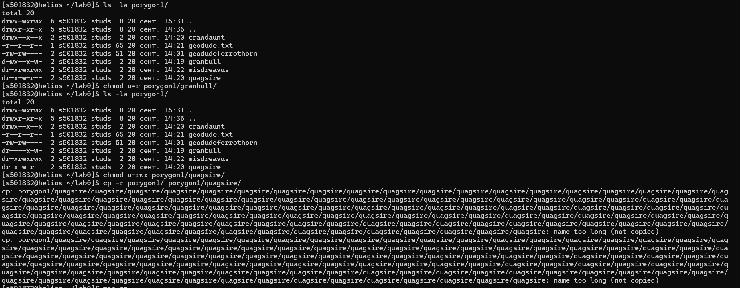

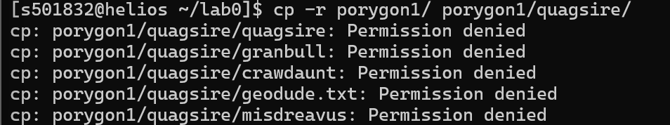

mkdir lab0
cd lab0
echo "Развитые способности Weak Armor" > ferrothorn5.txt
echo -e "Тип диеты \nOmnivore" > rattata8.txt
echo "satk=3 sdef=3 spd=9" > taillow2.txt
mkdir lopunny0 porygon1 swoobat3

cd lopunny0
mkdir jumpluff sandile kabuto
echo -e "Ходы \nEndeavor fire Punch Heat Wave Sleep Talk Snore Superpower Uproar Zen \nHeadbutt" > darmanitan.txt
echo -e "Ходы Air Cutter Defog Endeavor Heat Wave Mud-Slap \nOminous Wind Roost Sleep Talk Snore Swift Tailwind \nTwister" > starly.txt
echo -e "Тип покемона WATER NONE" > golduck.txt

cd ..
cd porygon1
mkdir granbull quagsire crawdaunt misdreavus
echo -e "Способности \nMountain Peak Landslide Sturdy Rock Head" > geodude.txt

cd ..
cd swoobat3
mkdir woobat pawniard
echo -e "Ходы Aqua Tail Avalanche Body Slam Dive Double-Edge \nDrill Run Icy Wind# Iron Tail Signal Beam# Sleep Talk Snore Water \nPulse" > dewgong.txt
echo -e "Развитые способности Rain Dish Water \nAbsorb" > pelipper.txt
echo -e "Способности Bite Roar Ember Leer Odor Sleuth \nHelping Hand Flame Wheel Reversal Fire Fang Take Down Flame Burst \nAgility Retaliate Flamethrower Crunch Heat Wave Outrage Flare \nBlitz" > growlithe.txt

cd ..
chmod 660 ferrothorn5.txt
chmod 771 lopunny0
cd lopunny0
chmod 733 jumpluff
chmod u=rx,g=rwx,o=rw sandile
chmod 733 kabuto
chmod 044 darmanitan.txt
chmod 624 starly.txt
chmod 066 golduck.txt
cd ..
chmod 733 porygon1
cd porygon1
chmod 512 granbull
chmod 524 quagsire
chmod 711 crawdaunt
chmod 404 geodude.txt
chmod 577 misdreavus
cd ..
chmod 444 rattata8.txt
chmod 312 swoobat3
chmod 044 taillow2.txt

